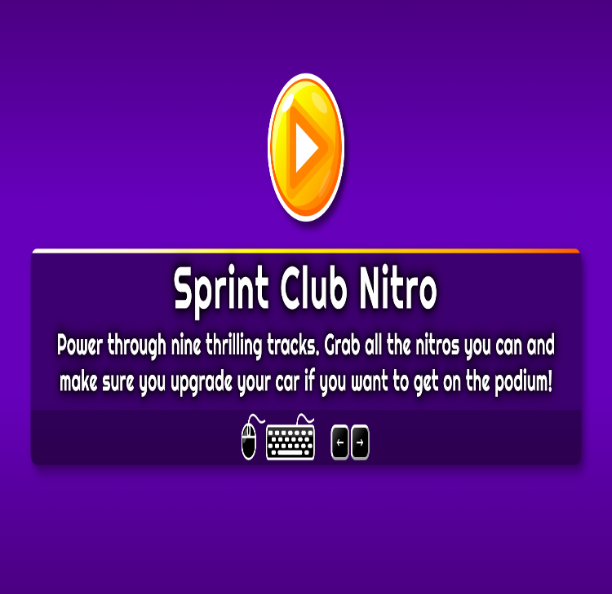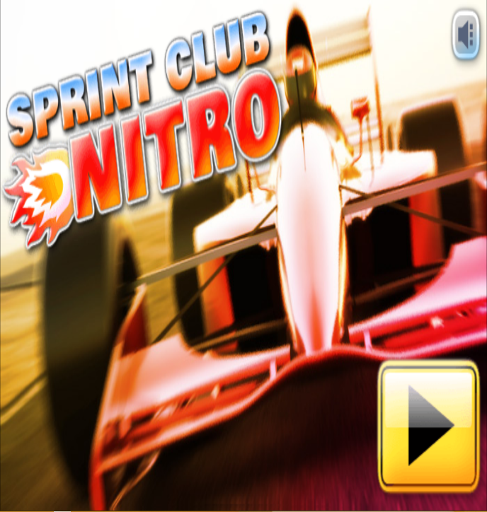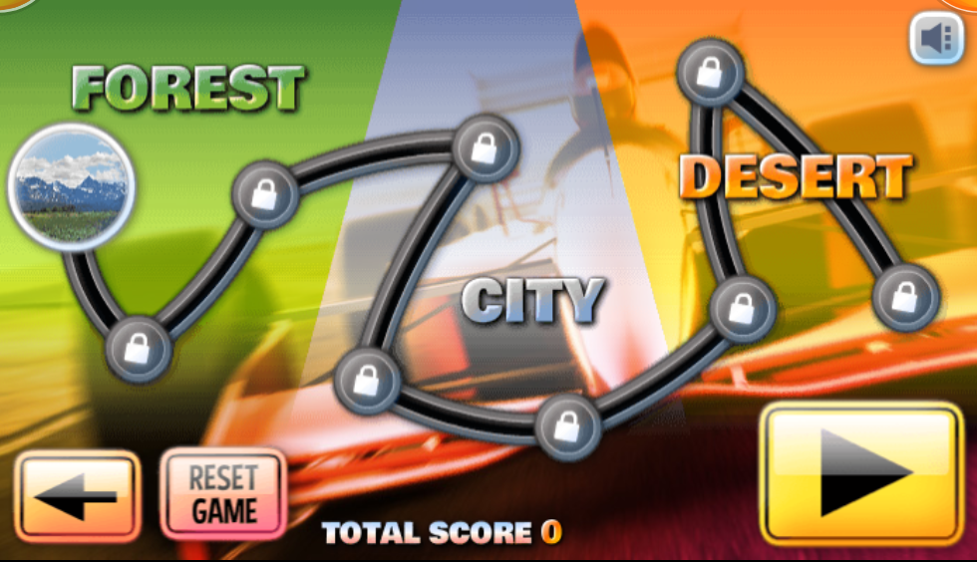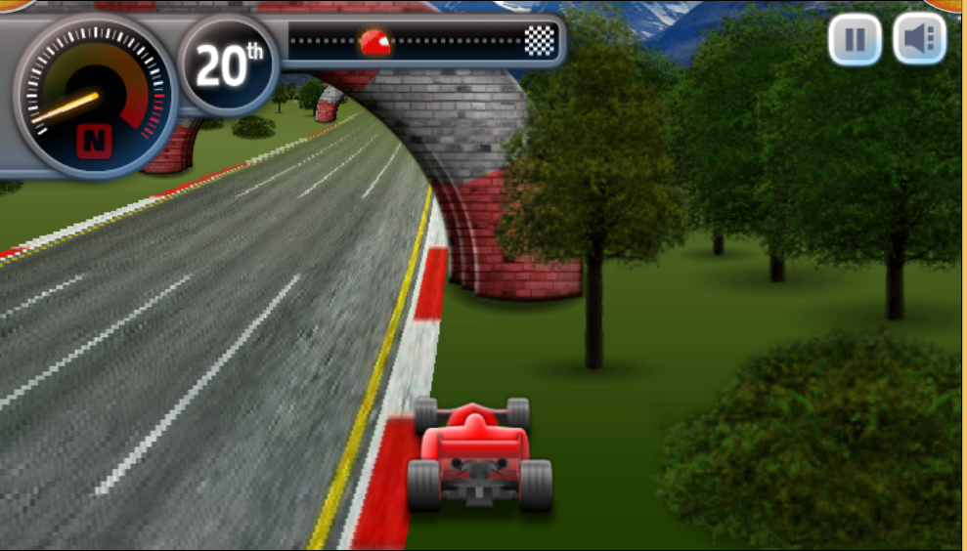

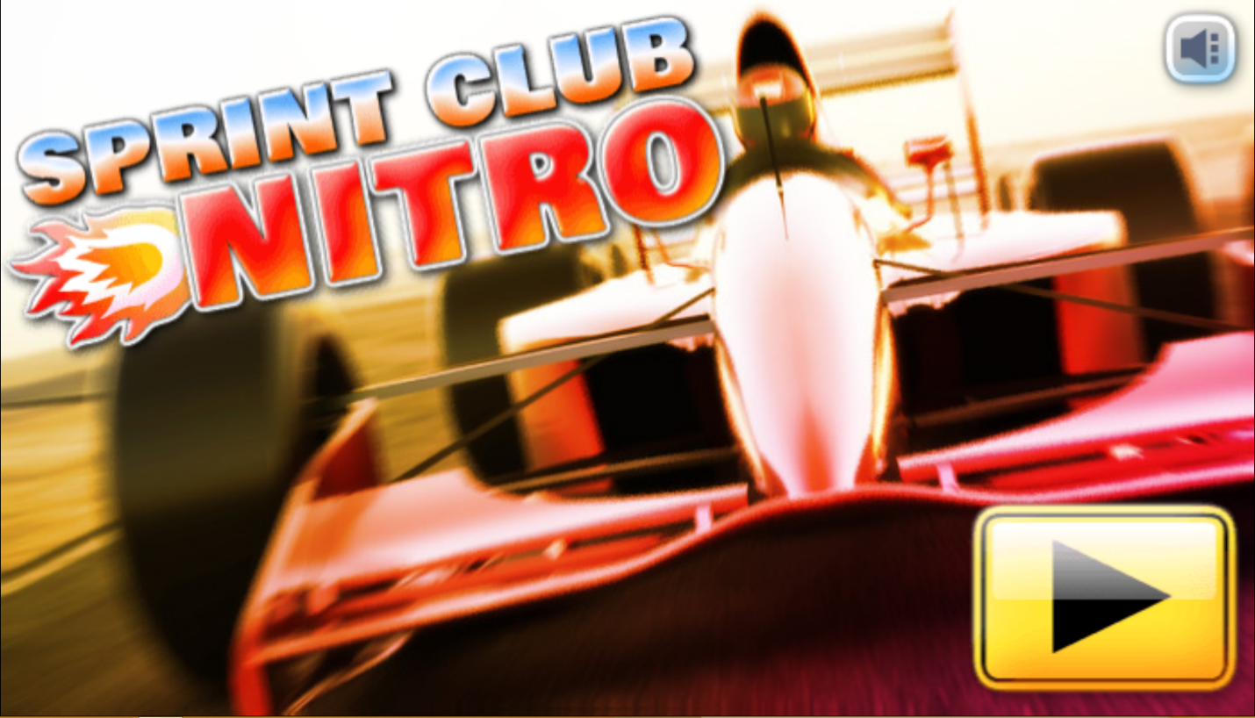

SPRINT CLUB NITRO

SUBMITTED BY:  
ROENICK SHAYNE R. MEDINA  
BSIT305

SUBMITTED TO:  
MR. RN SANTOS  
HCI INSTRUCTOR

Genre: 2d Side Scrolling, Racing

Target: Ages 10 and up

Rating: Rated E 10+

Number of Players: Single Player

Platform: PC

Gameplay:

The player will start to be last and the players must race till finish line and when it done the score will give it base on the place you got. The players key was only LEFT and RIGHT arrow only. Also, you can upgrade your car when the race is done.

Story:

The racer want to race anywhere. His mission is to be 1st place so he can win bigger price to upgrade his car. But it’s not going to be easy because some of the racer their car is faster than his car so he must win large price to upgrade his car and make it faster than any racer.